**FACE DETECTION APP CREATION USING AWS**

**AWS LOGIN SCREEN WITH USERNAME**

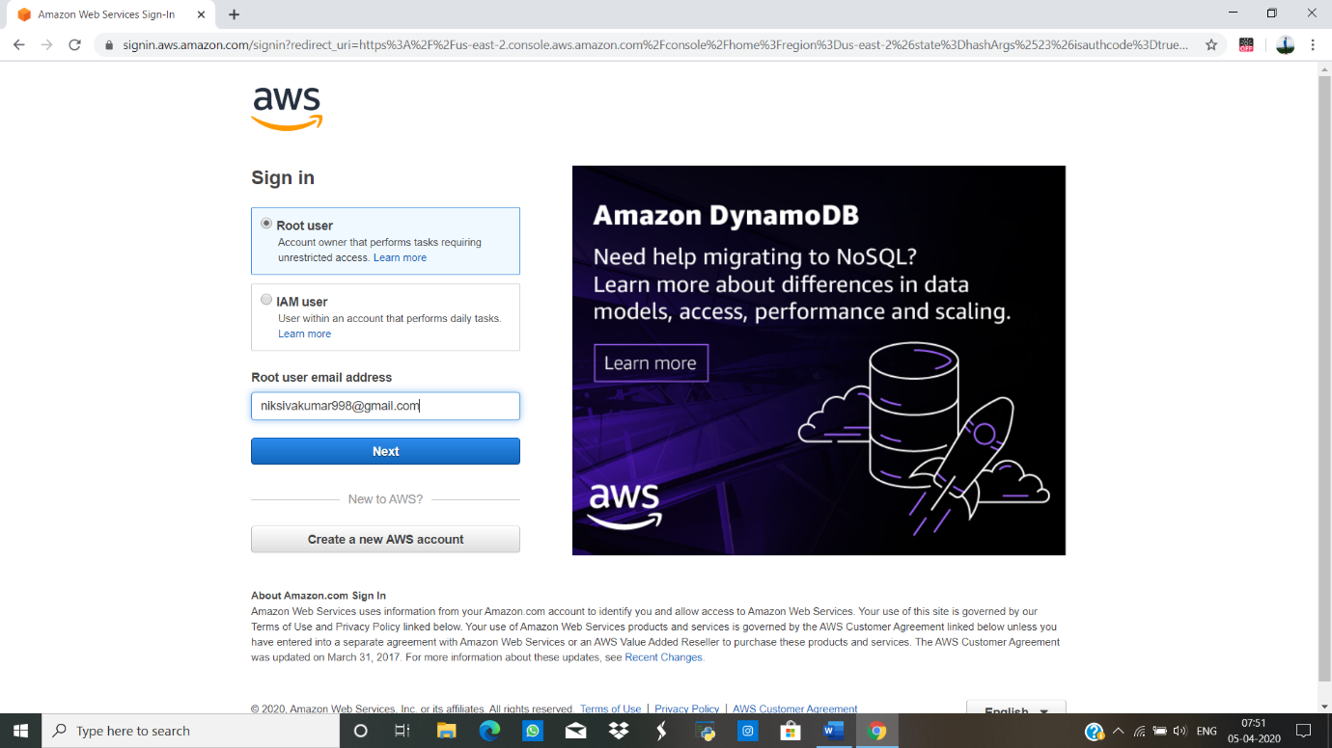

**AWS HOME PAGE**

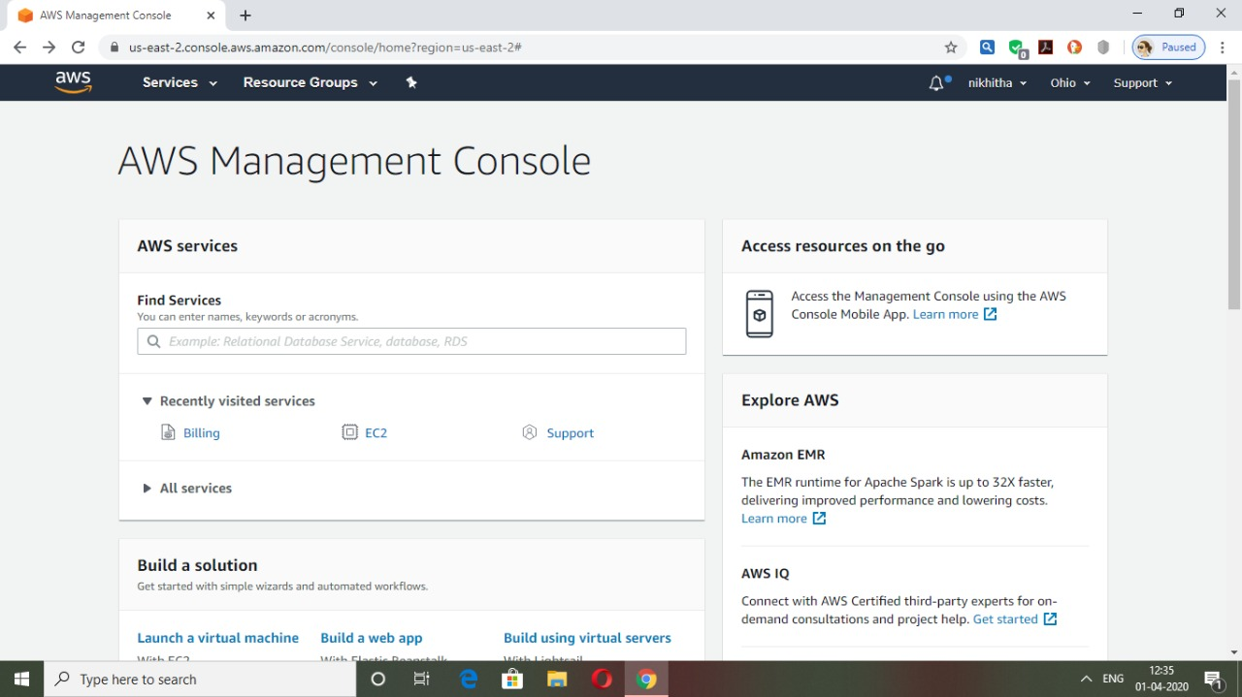

**EC2 DASHBOARD:**

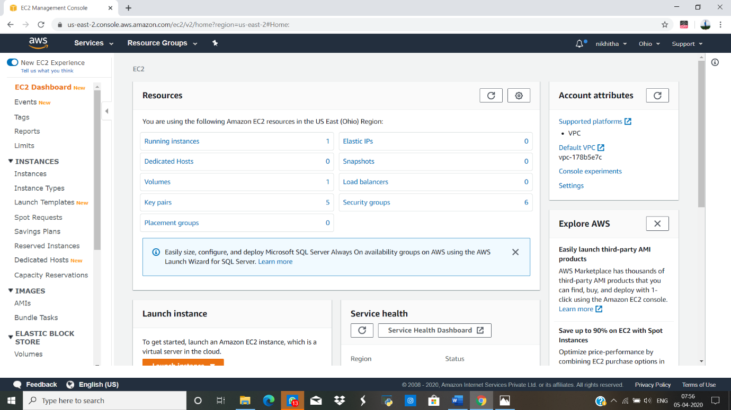

**S3 DASHBOARD**

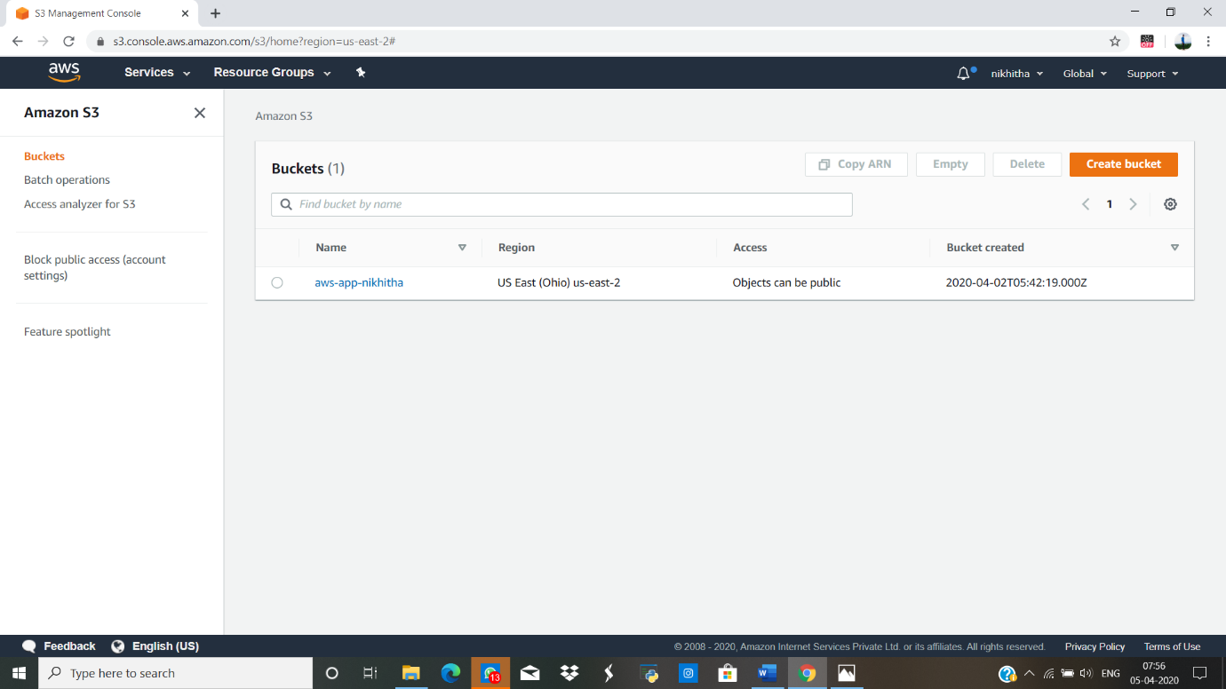

**REKOGNITION DASHBOARD**

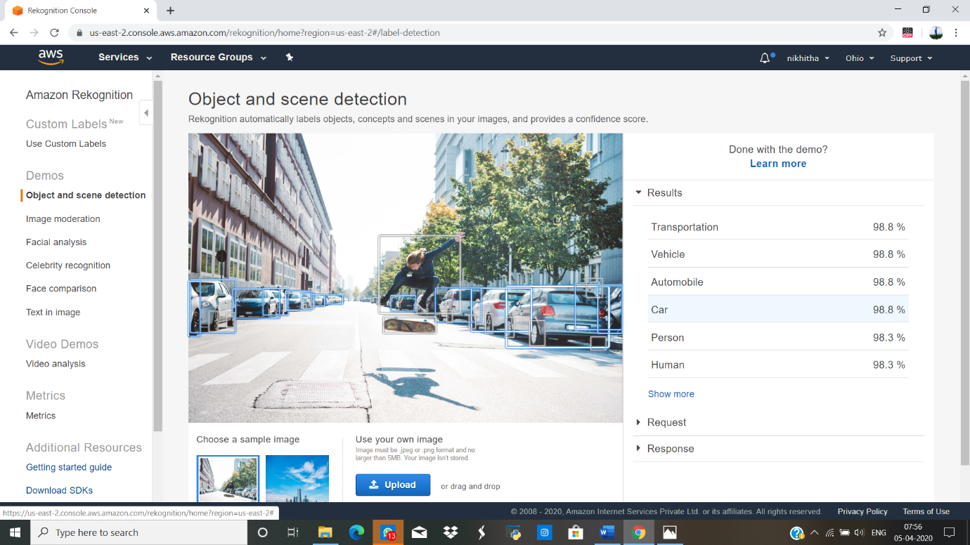

**EC2(ELASTIC CLOUD COMPUTE)**

**CHOOSING AN AMI**

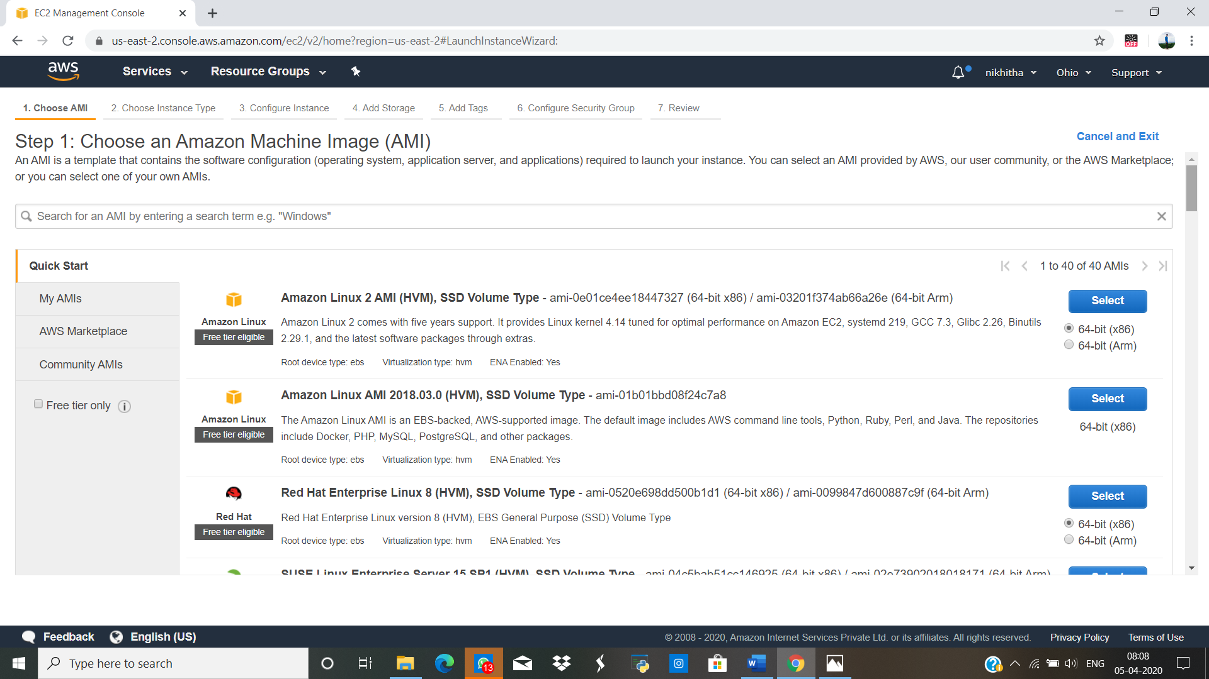

**CHOOSING AN INSTANCE TYPE**

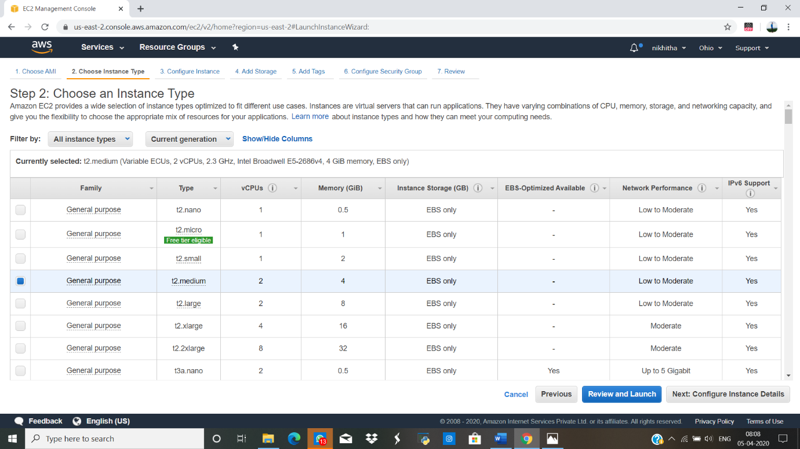

**ADDING STORAGE**

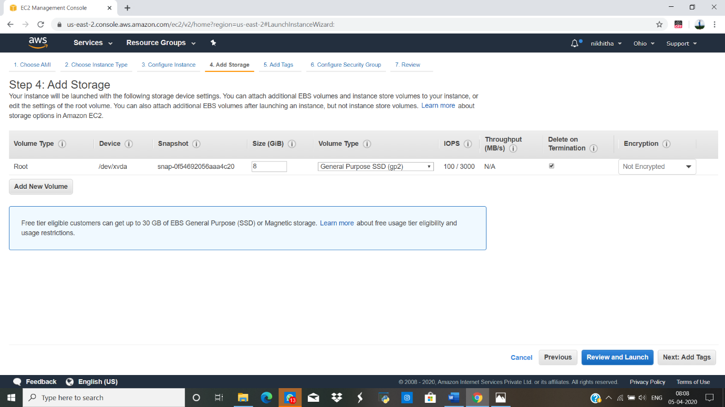

**CONFIGURING SECURITY GROUP**

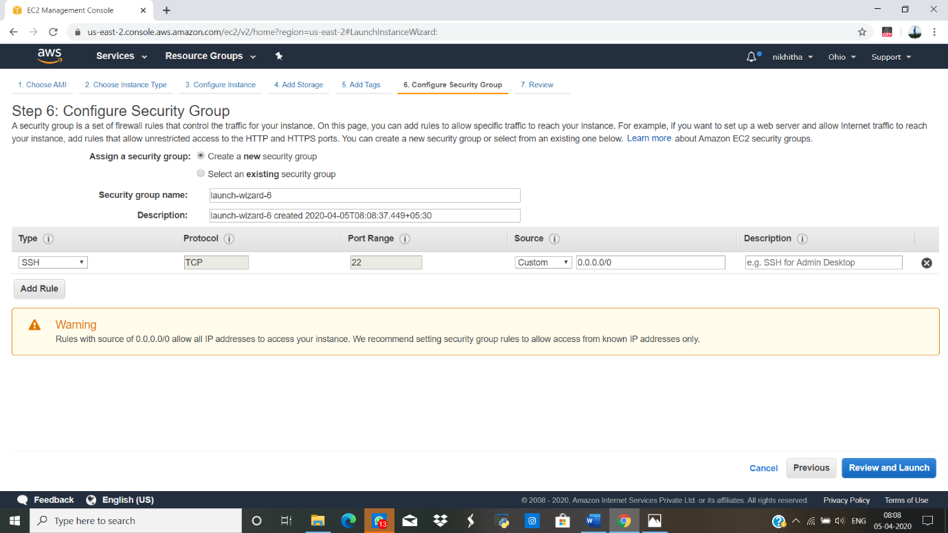

**KEY PAIR DOWNLOAD**

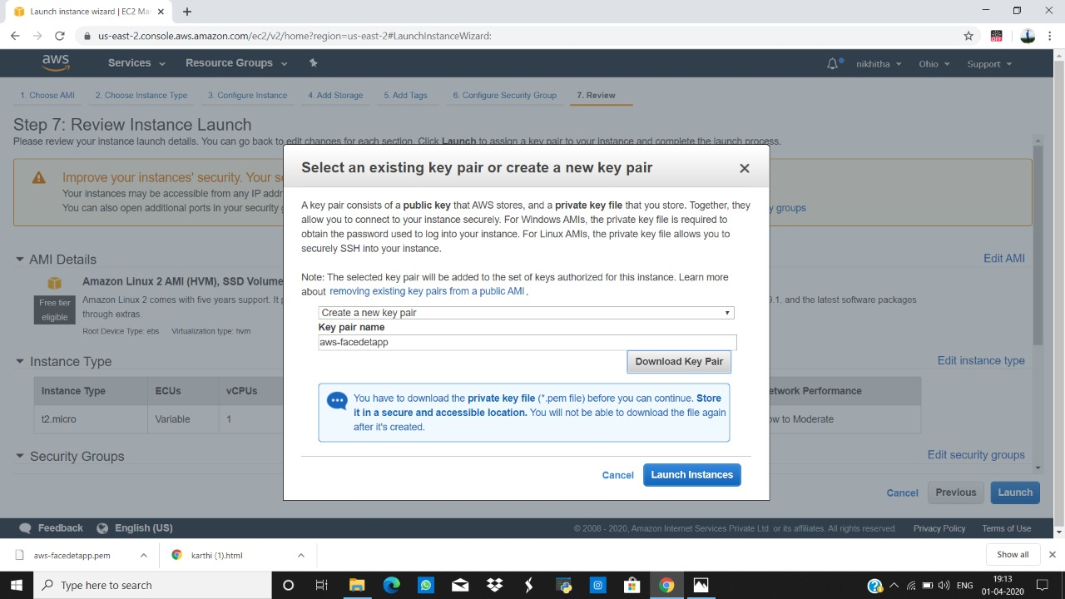

**PUTTYGEN CONVERSION FROM PEM TO PPK**

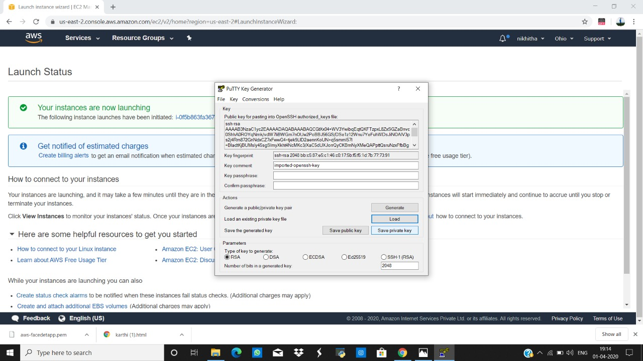

**PUTTYGEN CONVERSION FROM PEM TO PPK**

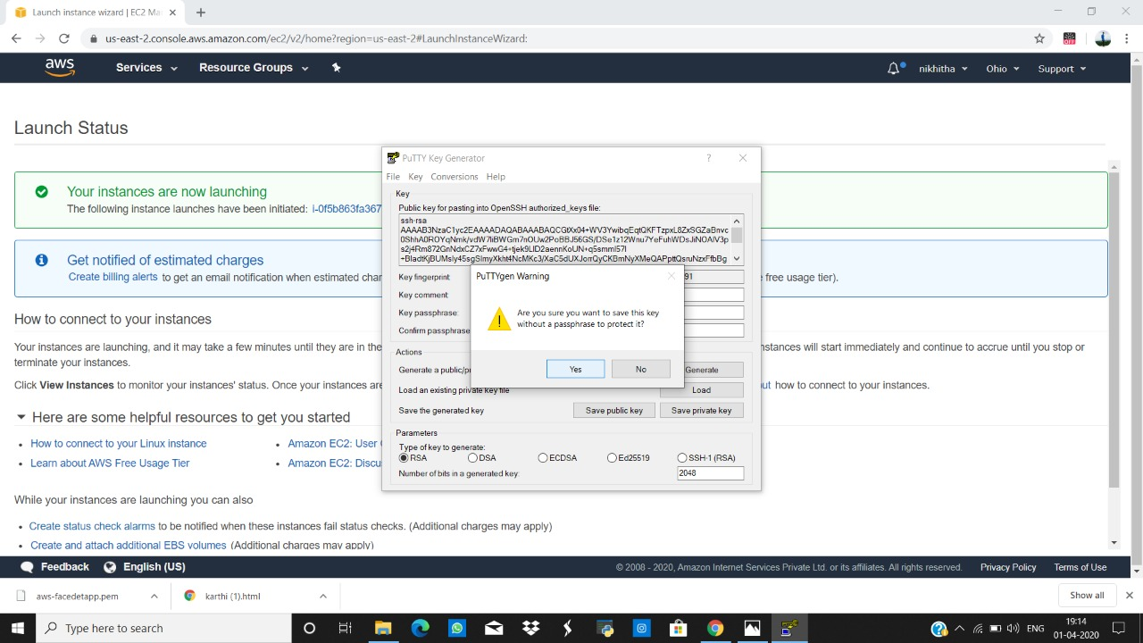

**LOGGED IN EC2 BLACK SCREEN**

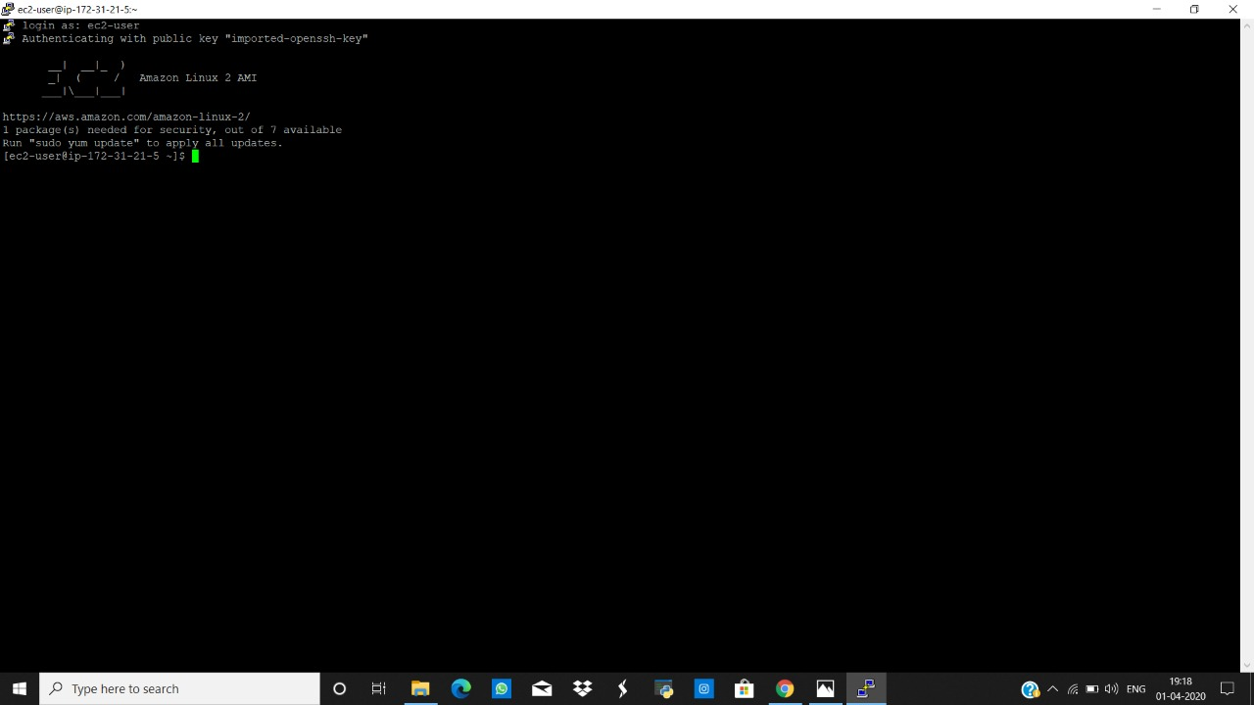

**S3(SIMPLE STORAGE SERVICE)**

**CREATING A BUCKET**

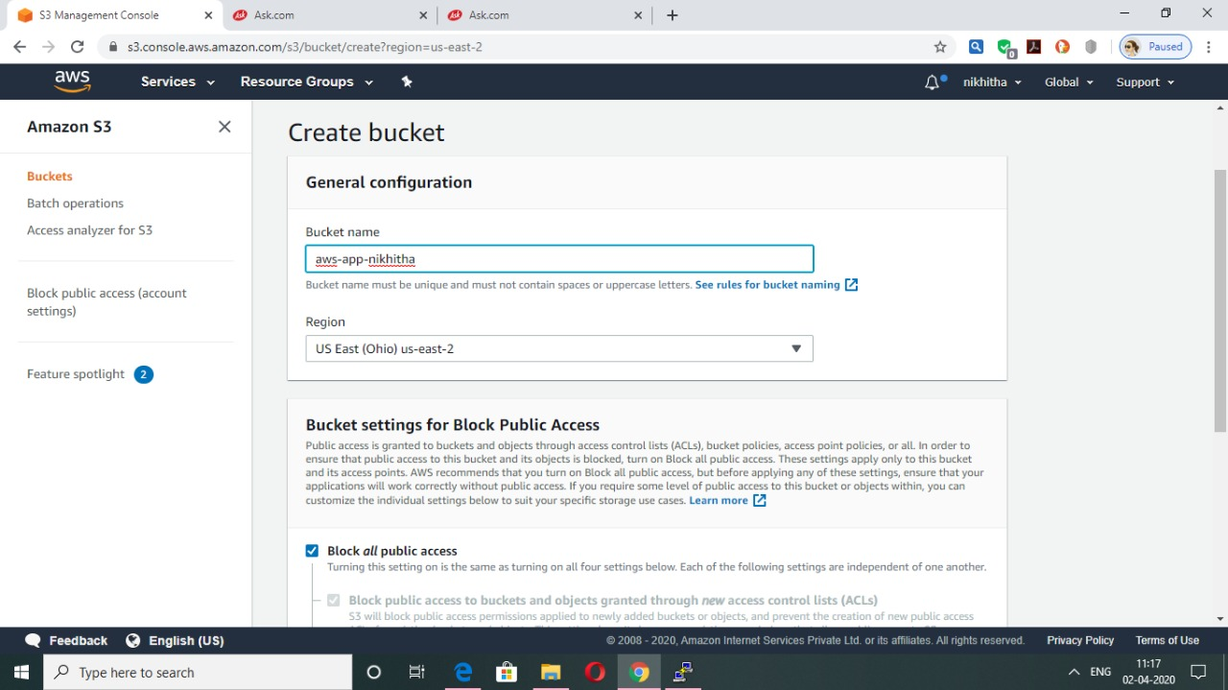

**UPLOADING AN OBJECT**

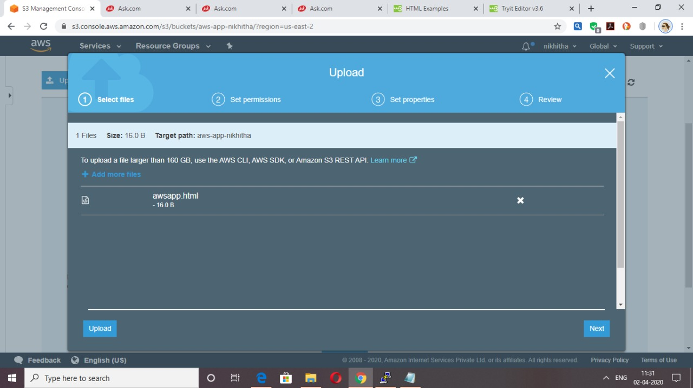

**ENABLING STATIC WEBSITE**

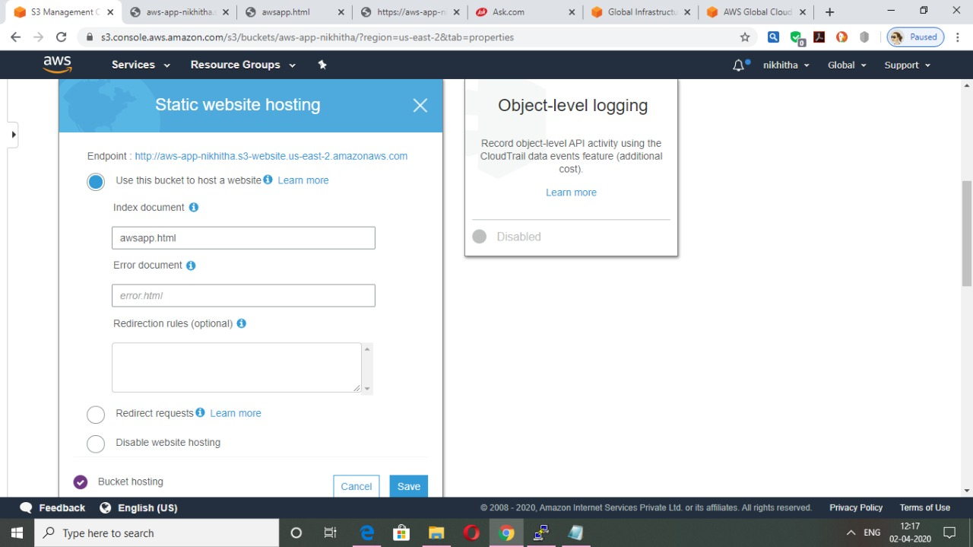

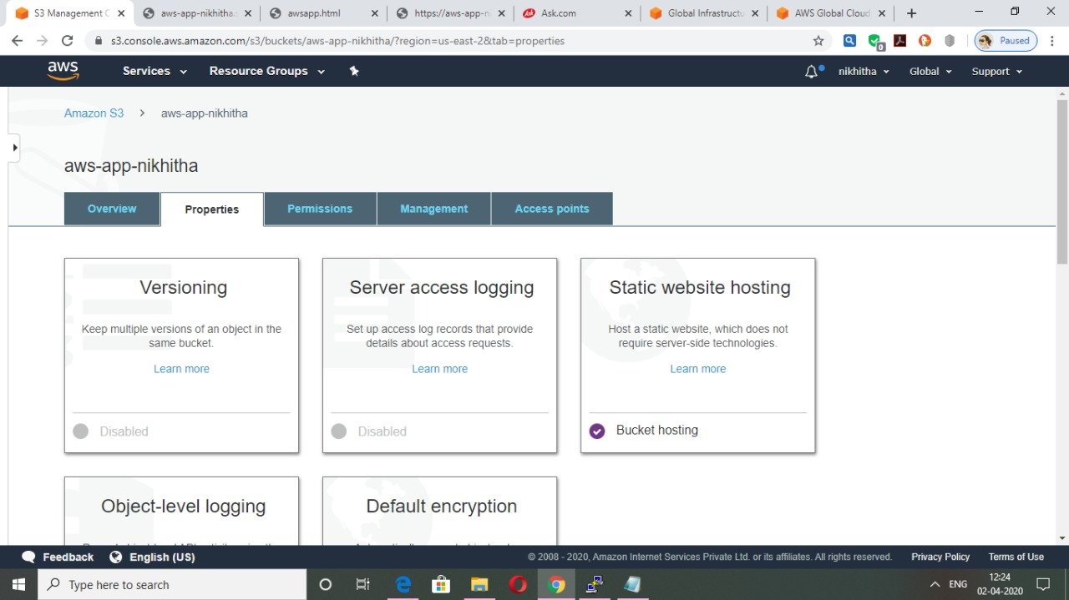

**UNBLOCK PUBLIC ACCESS**

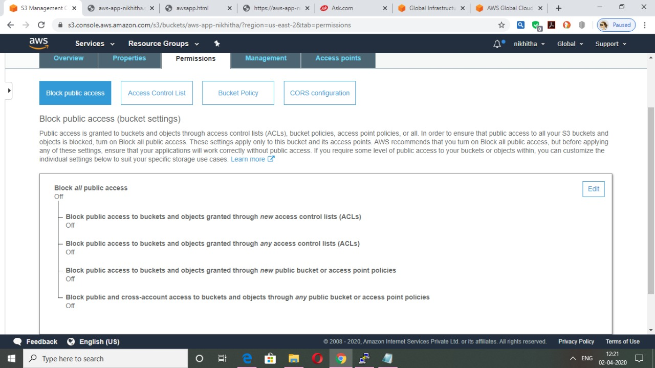

**MAKE THE OBJECT PUBLIC**

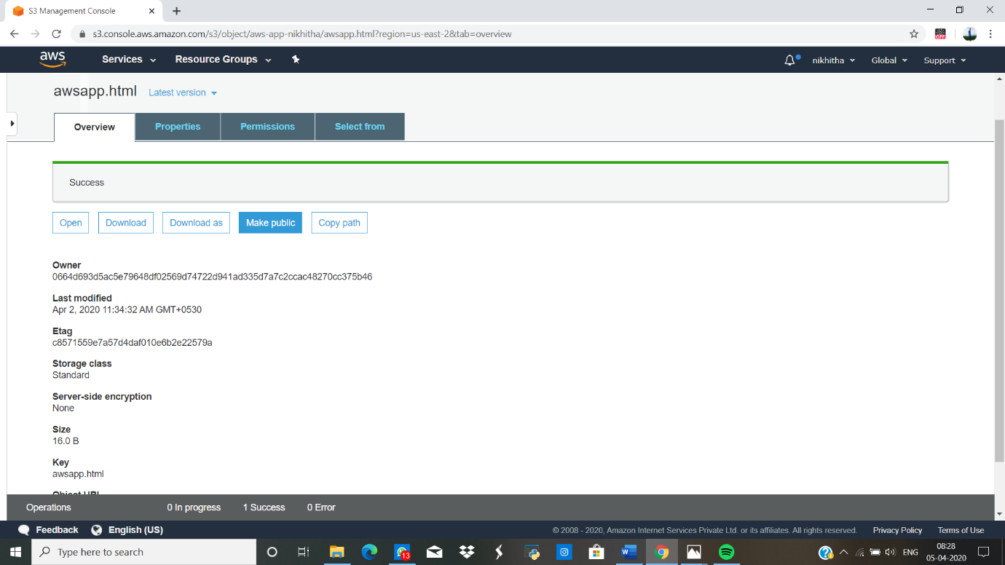

**CHECKING THE S3 LINK ON THE BROWSER**

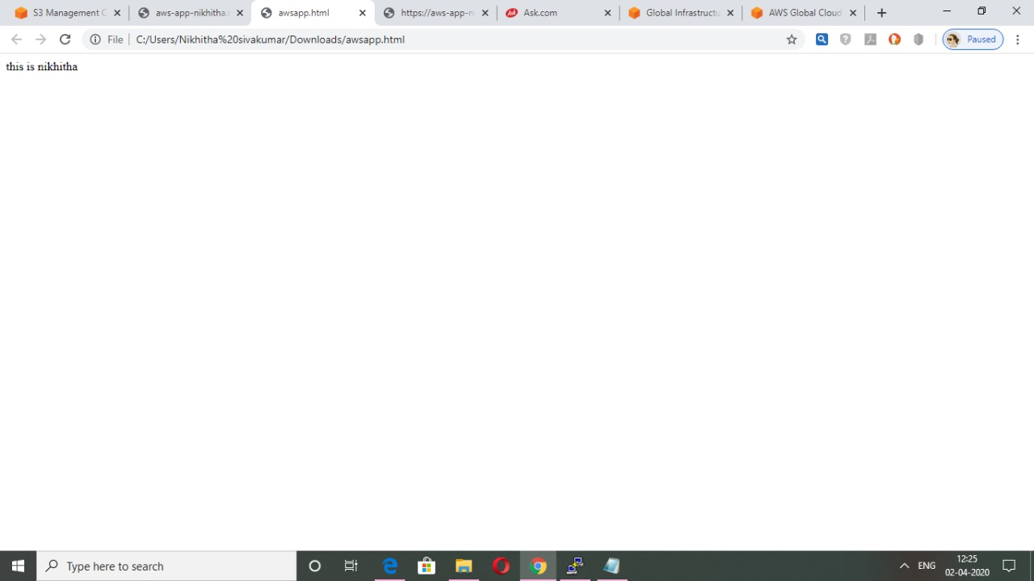

**REKOGNITION**

**FACE DETECT**

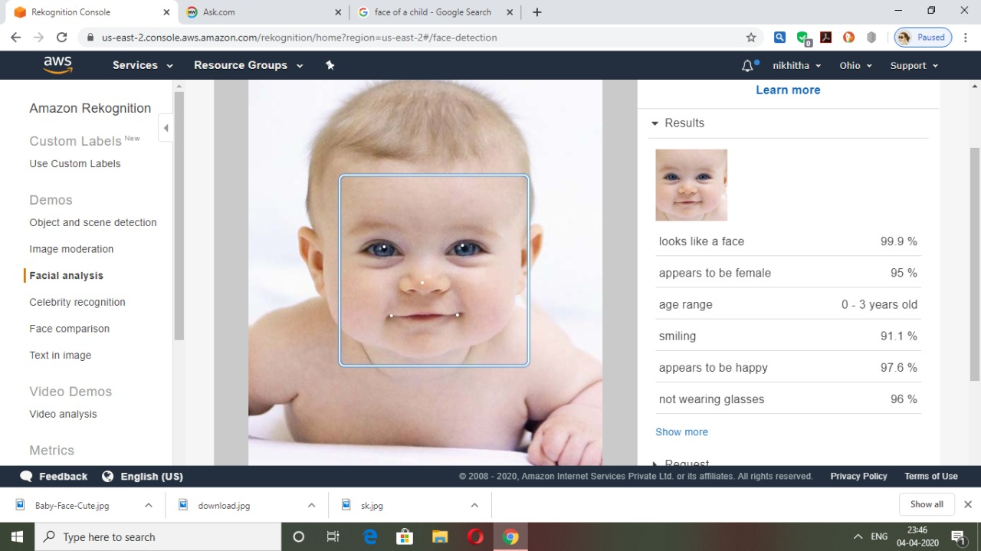

**FACE COMPARE**

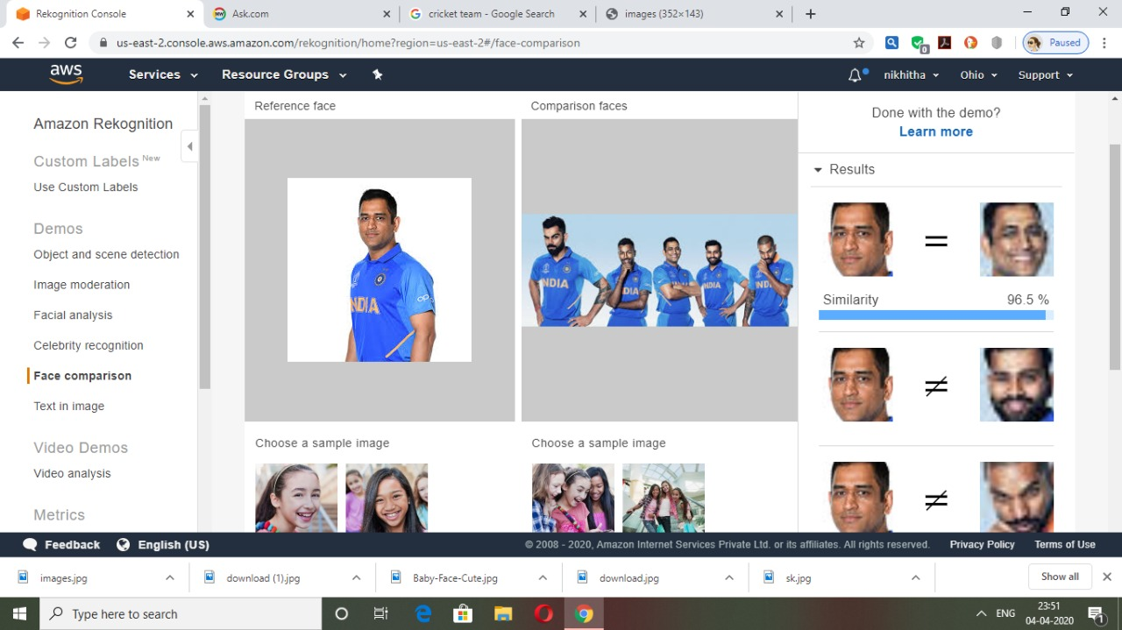

**CELEBRITY RECOGNITION**

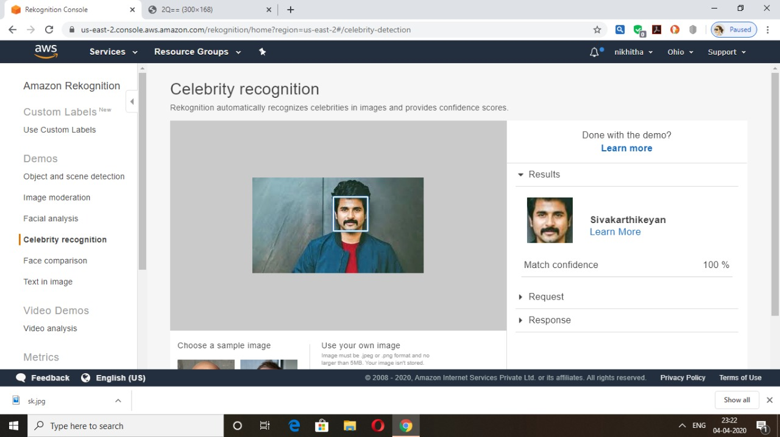

**TEXT IN IMAGE**

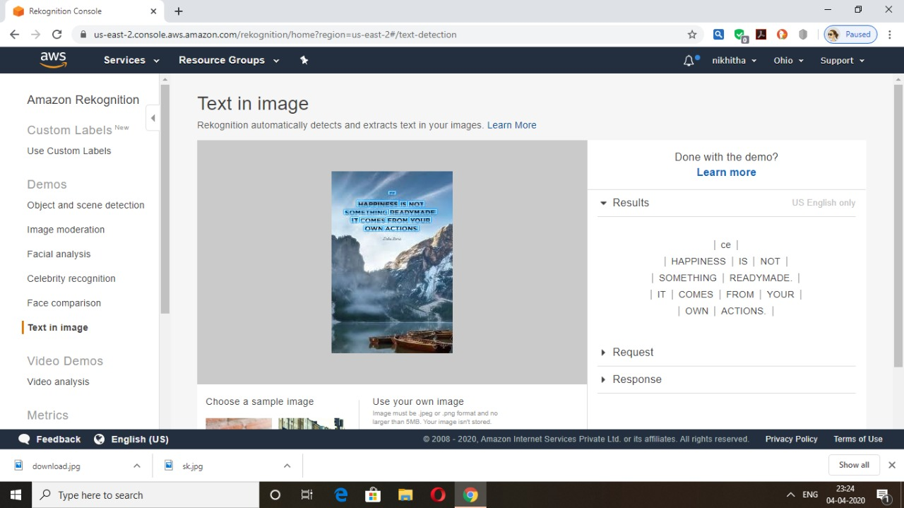

**EC2 AND S3**

**INSTALLING AWS SDK**

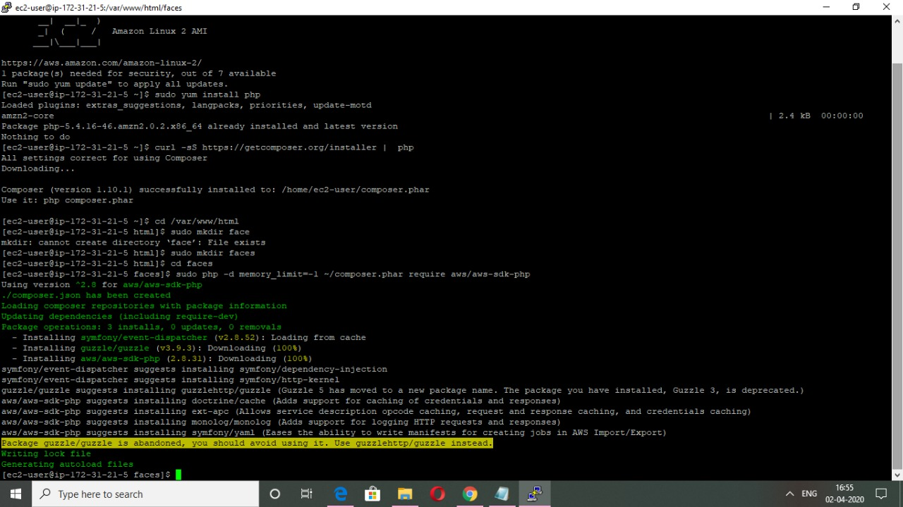

**INSTALLING PHP**

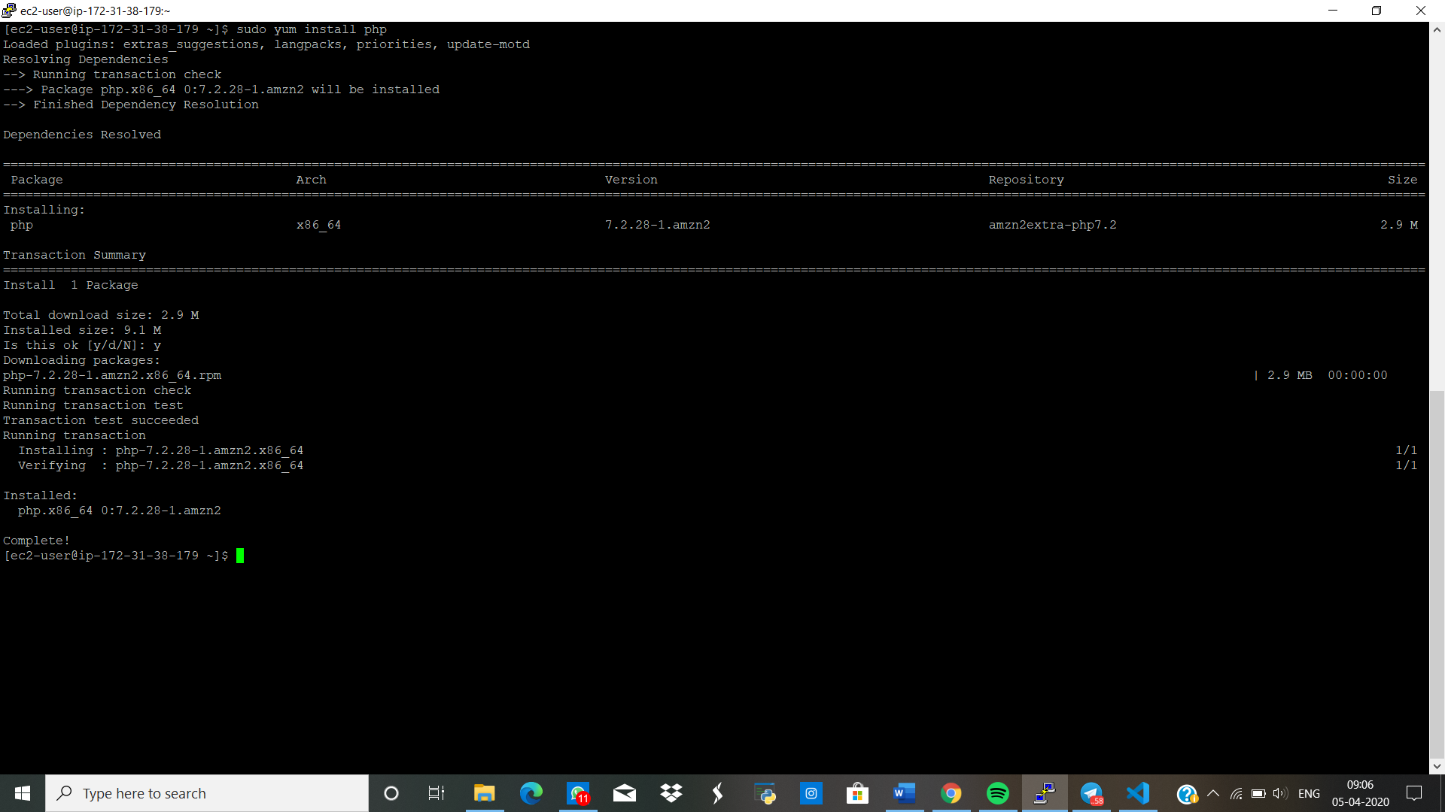

**INDEX.PHP FILE CODE**

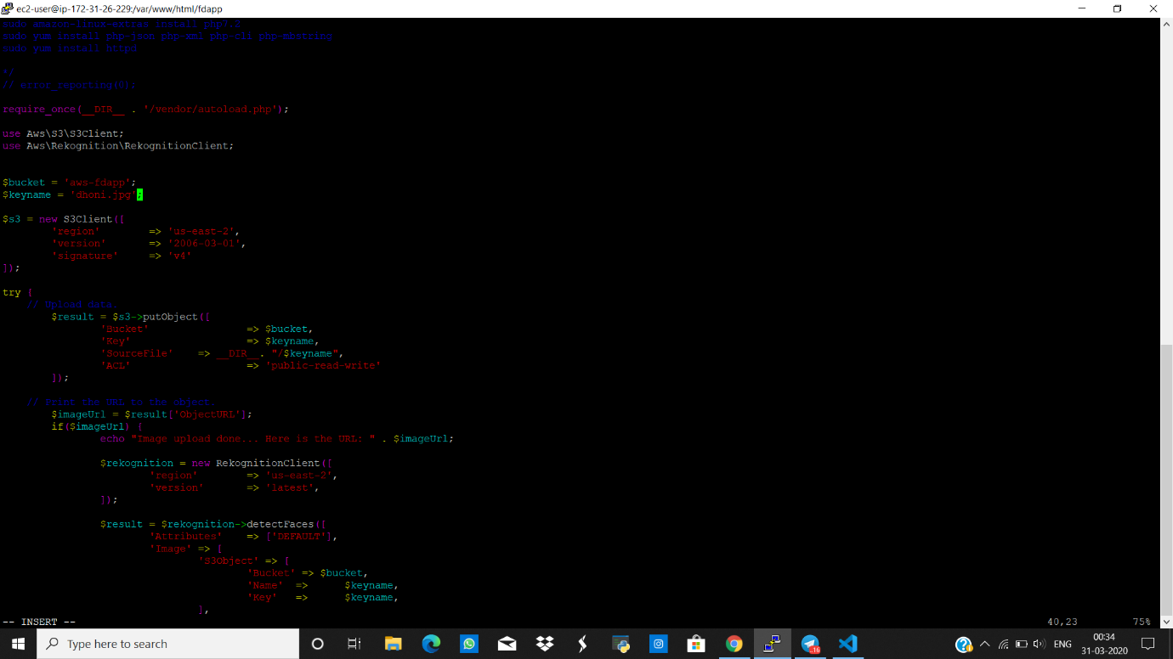

**PHP COMPSER INSTALLATION**

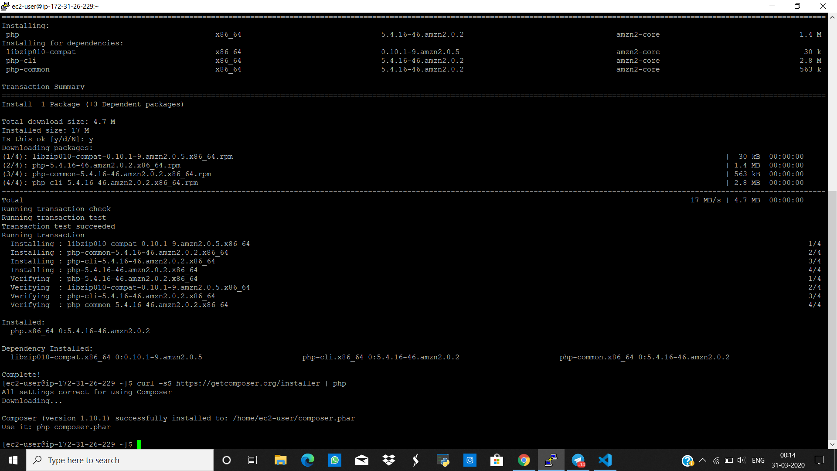

**UPLOAD SUCCESS SCREENSHOT**

